User Manual

*Go to : https://social-awarness-govardhan.herokuapp.com/*

Admin Credential :

*username :* [*admin@admin.admin*](mailto:admin@admin.admin)

*password : admin*

Regular Credential:

*username : dummy@email.com*

*password : dummy*

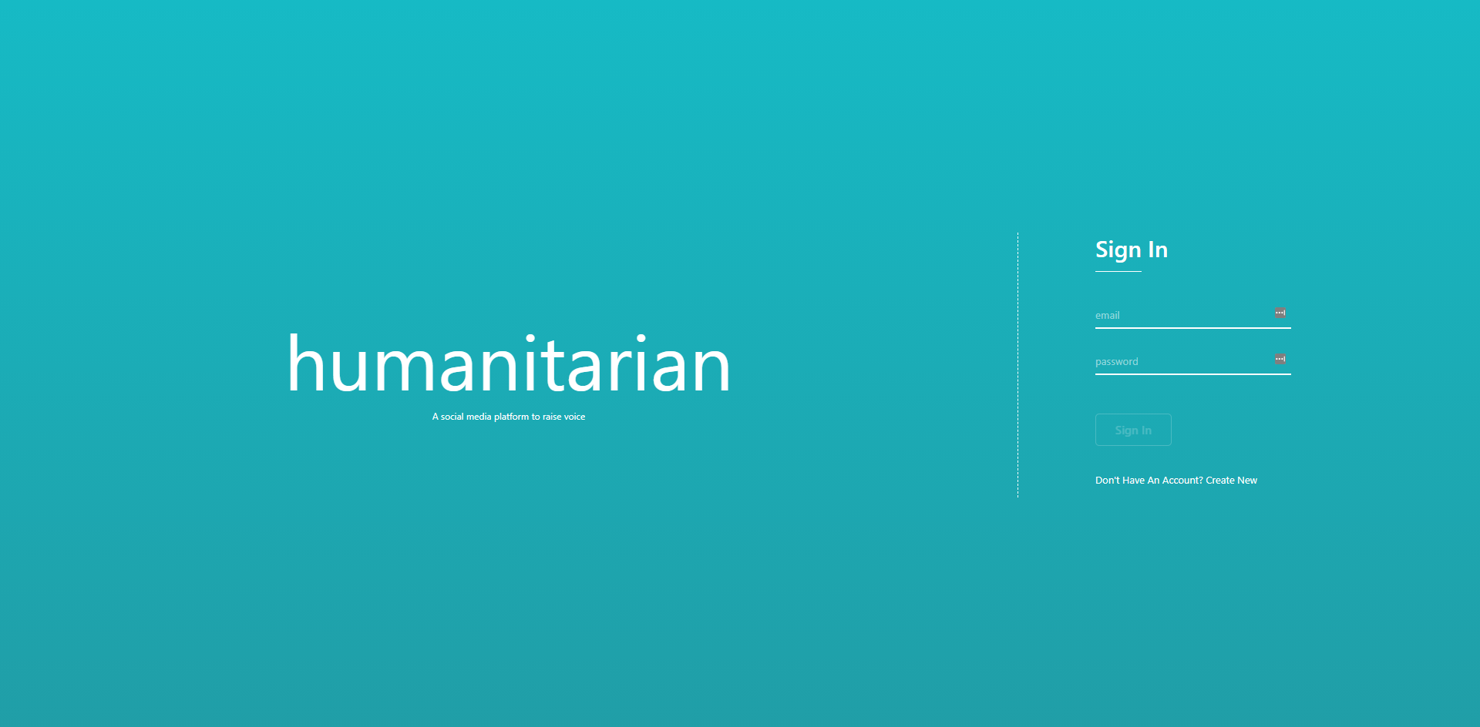

When user signs in to the app, user will be navigated to below page by the app itself

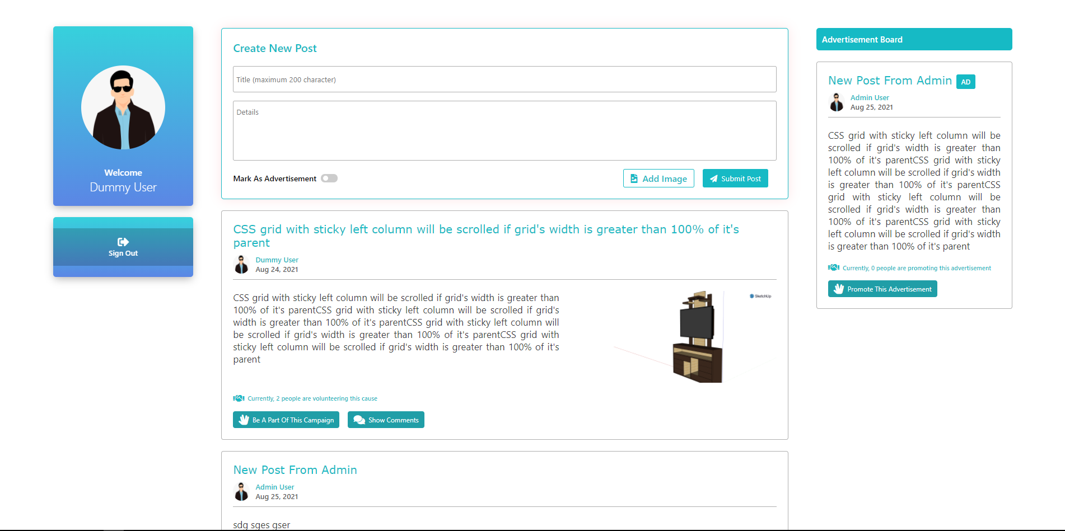

The form on top is responsible for gathering the data for creating new thread.

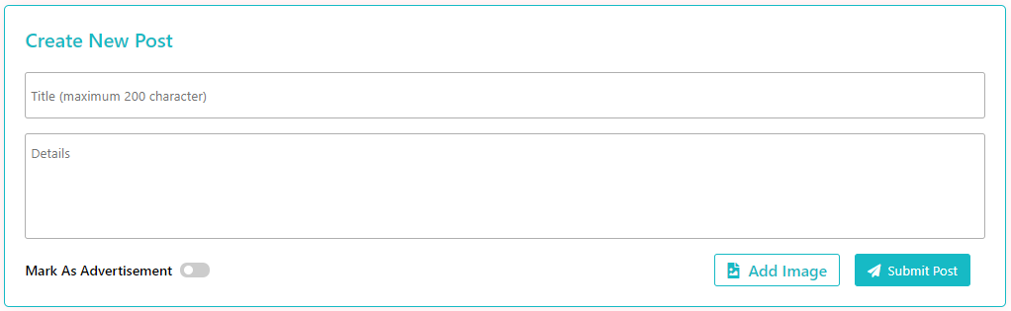

User can volunteer a post by clicking **Be A Part Of This Campaign** or view the comment created by users on clicking **Show Comments**

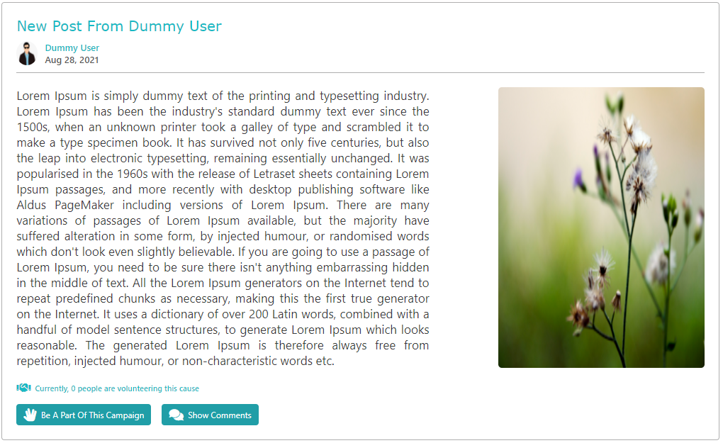

If the user log in as admin, they can view beneath options in top bar

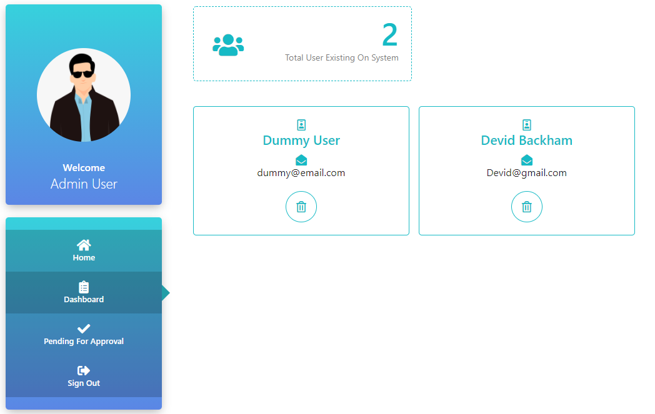

When they navigate to **Posts pending for approval**, they view net page, where they can see a list of posts which are waiting for approval from admin

